“So shall we keep the unity of the spirit in the bond of peace. The Lord will be our God, and delight to live among us. We are his one people. He will command a blessing upon us in all our ways. So that we shall see much more of his wisdom, power, goodness and truth than we have been acquainted with before. We shall find that the God of Israel is among us. We will know this when ten of us shall be able to resist a thousand of our enemies; when he shall make us a praise and glory that men shall say of succeeding plantations, "the Lord make it likely that of New England." For we must consider that we shall be as a city upon a hill. The eyes of all people are upon us. So that if we shall deal falsely with our God in this work we have undertaken, and so cause him to withdraw his present help from us, we shall be made a story and be dishonorable through the world. We shall open the mouths of enemies to speak evil of the ways of God, and all professors for God's sake. We shall shame the faces of many of God's worthy servants. We shall cause their prayers to be turned into curses upon us till we are forced to leave the good land where we are a-going.”
“Model of Christian Charity.” John Winthrop, 1630. Speech.

“IN THE NAME OF GOD, AMEN. We, whose names are underwritten, the Loyal Subjects of our dread Sovereign Lord King James, by the Grace of God, of Great Britain, France, and Ireland, King, Defender of the Faith, &c. Having undertaken for the Glory of God, and Advancement of the Christian Faith, and the Honour of our King and Country, a Voyage to plant the first Colony in the northern Parts of Virginia; Do by these Presents, solemnly and mutually, in the Presence of God and one another, covenant and combine ourselves together into a civil Body Politick, for our better Ordering and Preservation, and Furtherance of the Ends aforesaid: And by Virtue hereof do enact, constitute, and frame, such just and equal Laws, Ordinances, Acts, Constitutions, and Officers, from time to time, as shall be thought most meet and convenient for the general Good of the Colony; unto which we promise all due Submission and Obedience. IN WITNESS whereof we have hereunto subscribed our names at Cape-Cod the eleventh of November, in the Reign of our Sovereign Lord King James, of England, France, and Ireland, the eighteenth, and of Scotland the fifty-fourth, Anno Domini; 1620”
“Mayflower Compact.” William Bradford, 1620. Government document.

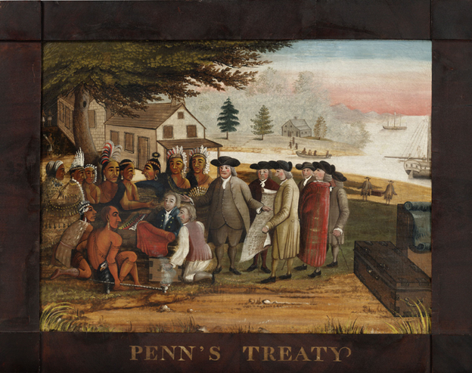
“Penn’s Treaty with the Indians.” Edward Hicks, 1830-1835. Oil painting.

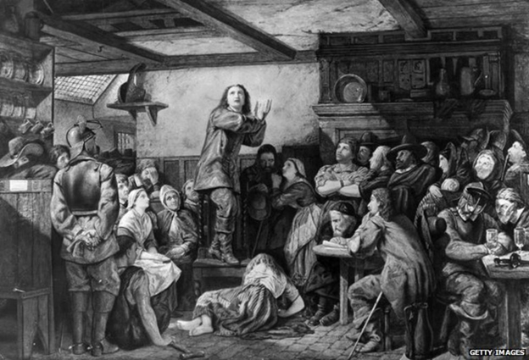
“George Fox, preaching in a tavern.” Unknown artist, circa 1650. Painting.

“Indentured servants
Indentured servants became the first way to meet the need for workers [to grow tobacco]. In return for a free boat ride to Virginia, an indentured servant worked for four to five years in the fields. Then he or she was given freedom. England rewarded farmers with 50 acres of land for every person they brought to the New World.
It was hard for landowners to keep indentured servants and slaves. Servants and slaves often ran away from abusive masters. Virginia lawmakers passed laws that would punish servants and slaves, sometimes branding them.”
“The Growth of Tobacco in America.” USHistory.org, adapted by NewsELA, 2017. Article.

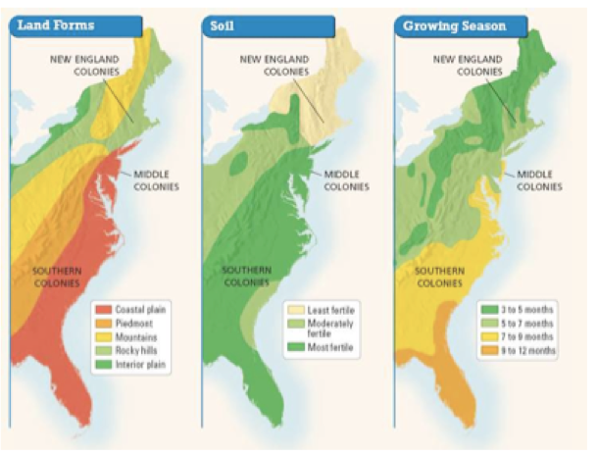
“Geographical differences.” Humboldt State University Department of History, 2018. Map.

